|  |  |
| --- | --- |
| **Ex No: 3** | Leap Year Calculation |

**AIM**

Write a C program to find the program to find whether the given year is leap year or Not.

(Hint: not every centurion year is a leap. For example 1700, 1800 and 1900 is not a leap year)

**PRE-LAB QUESTIONS**

1. What do you mean by case-sensitive? Is C a case-sensitive language?
2. What are the different data types in C?
3. Mention the applications of C language
4. What do you mean by C tokens
5. What are keywords

**ALGORITHM**

**Step 1:** Start  
**Step 2:**  Read year  
**Step 3:** If year is divisible by 4 and not divisible by 100   
 or year is divisible by 400,  
 print “leap year”  
**Step 4:**  Else, print “Not a leap year”  
**Step 5:** End

**FLOWCHART**

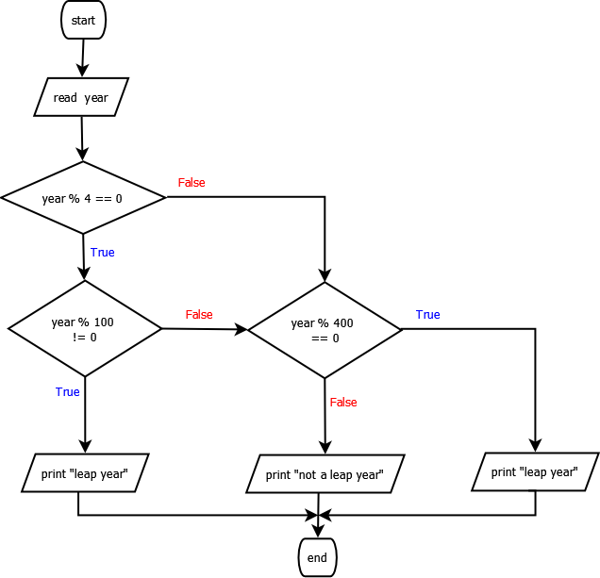

**PROGRAM**

#include<stdio.h>

void main**(){**

int year**;**

scanf**(**"%d"**,** **&**year**);**

**if** **(** **(**year **%** 4 **==** 0 **&&** year **%** 100 **!=** 0 **)** **||** year **%** 400 **==** 0**)**

printf**(**"leap year"**);**

**else**

printf**(**"Not a leap year"**);**

**}**

**INPUT**

**1700**

**OUTPUT**

**Not a leap year**

**POST-LAB QUESTIONS**

1. Mention three simple structures in structured programming
2. What is the output of the following code snippet:  
   a = 5, b = 10, c = -6  
   if(a == c || b > 0) printf(“true”);  
   else printf(“false”);
3. Write the use of switch…case construct with its syntax and example.
4. Differentiate a) Nested if-else statement and b) switch..case statement with example
5. Why do we need branching statements in C. Give examples.

**RESULT**

Thus the C program to find the program to find whether the given year is leap year or Not has been written, executed and verified successfully.